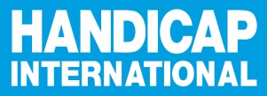
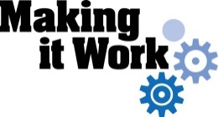

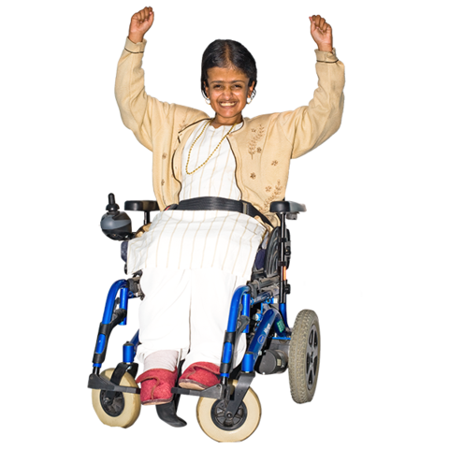

About Making it Work

What is Making it Work?

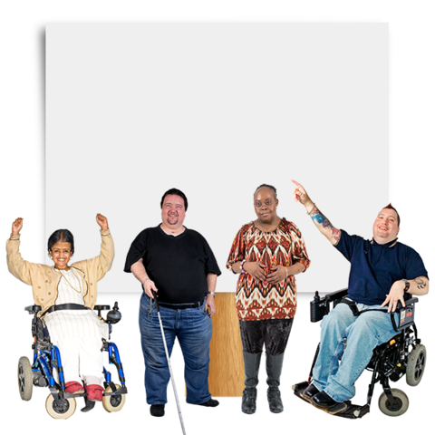
Making It Work is a project about making the lives of people with disabilities better.

Making it Work looks at lots of things to do with people with disabilities.

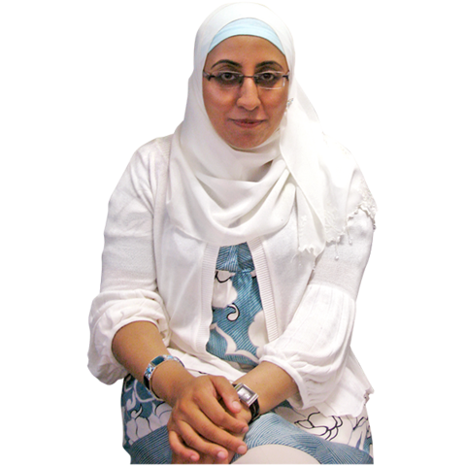

This part of the project is about women and girls with disabilities.

Why women and girls with disabilities?

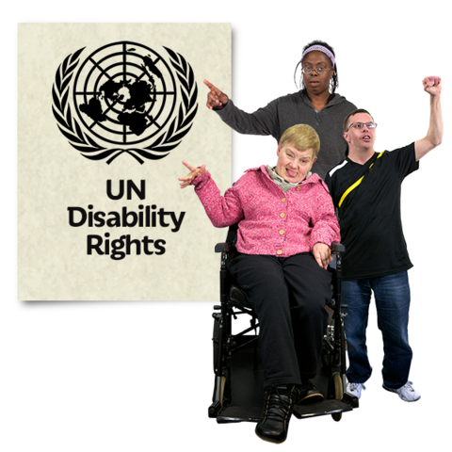
A document called
The Convention on the Rights of Persons with Disabilities talks about the rights of people with disabilities.

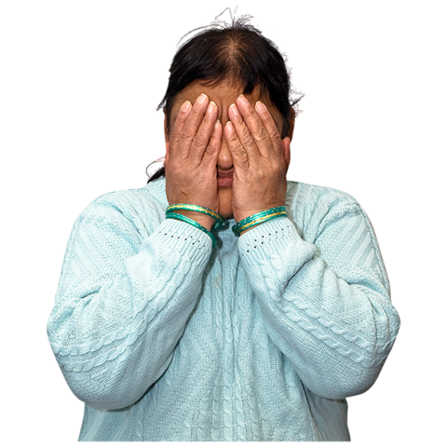

But many people with disabilities do not get their rights.

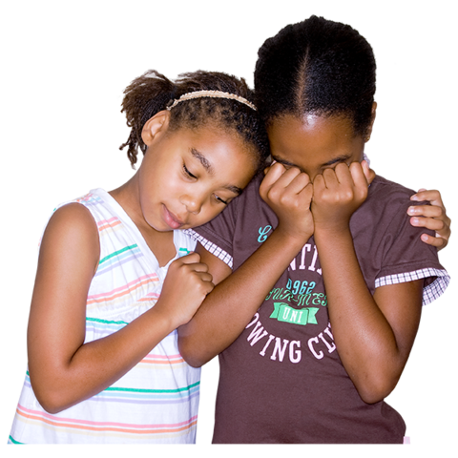

Life can be much worse for women and girls with disabilities.

For example, they are often hurt or treated badly by others.

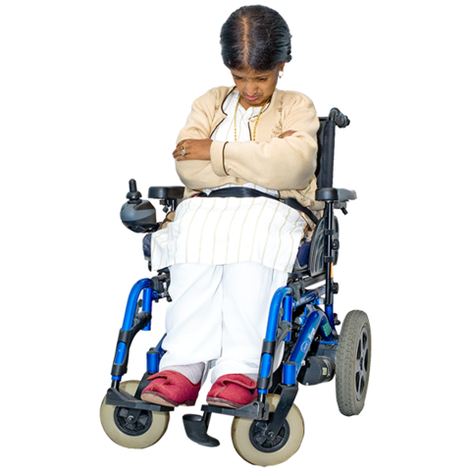

They are often left out and do not have a say in what happens.

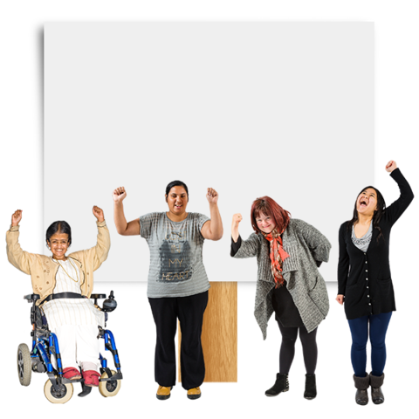
The Making it Work project is helping to change this.

It will help women and girls with disabilities say what needs to change to stop violence and make their lives better.

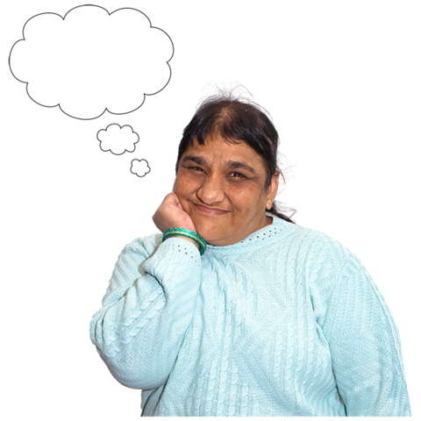
How does the project work?

The project looks at good ideas that:
- are happening already
- work well
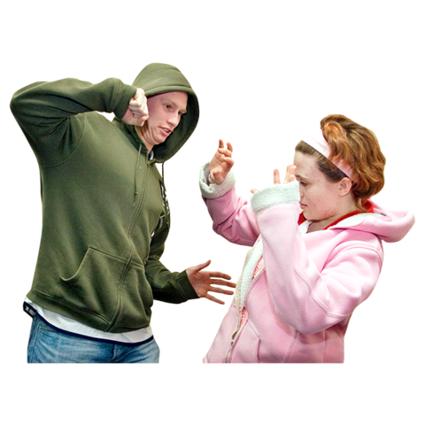

The ideas can help stop violence against women and girls with disabilities.

For example, some ideas are:
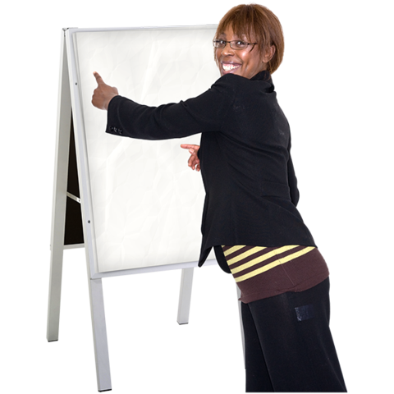
- training for women and girls with disabilities to help them know their rights

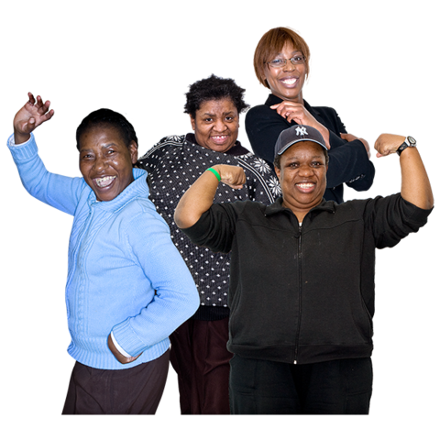
- training for other people to help them know how to treat women and girls with disabilities

- setting up groups of women and girls with disabilities so they can work together to change things

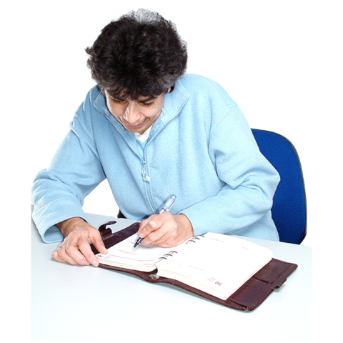
The Making it Work project helps people:

- find good ideas like this and write them down

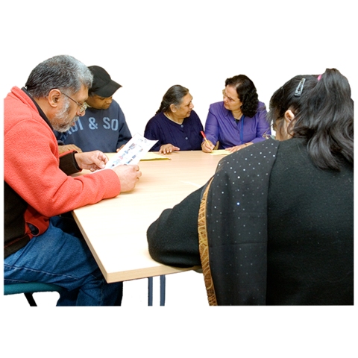

- find out what people with disabilities think of the ideas
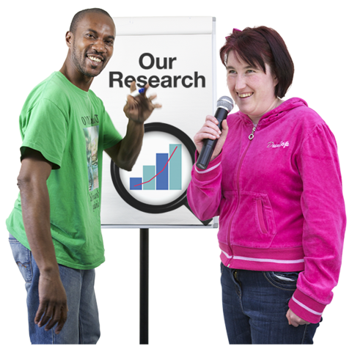
- share information about what works

- help more people use the good ideas

- use the ideas to change things

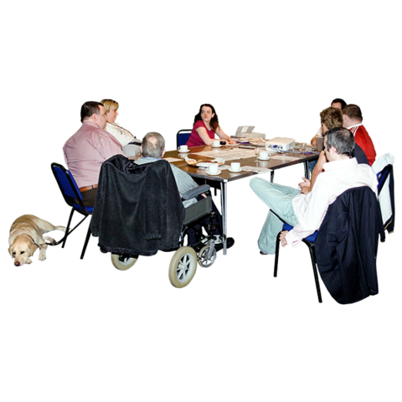
Making it Work is mainly for people with disabilities and the organizations that support them.

But anyone can take part.

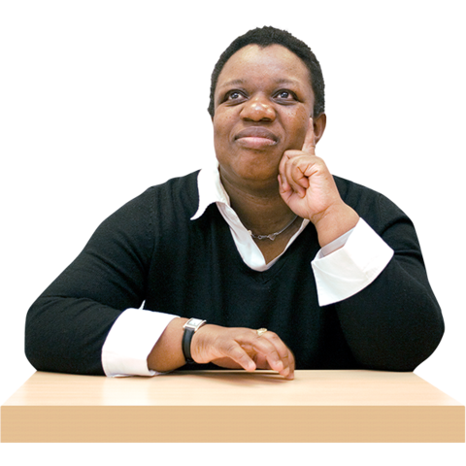
What has happened so far?

We asked people for good ideas about how to make the lives of women and girls with disabilities better.

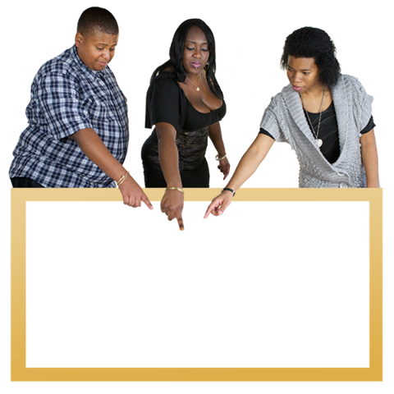

We chose 11 good ideas.

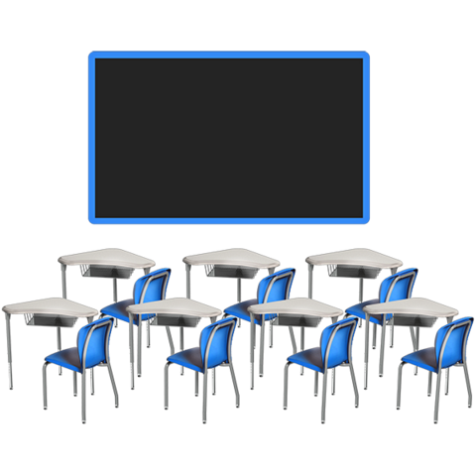
People are now using these ideas to help change things.

For example, there may be a project in one country to make schools better for girls with disabilities.
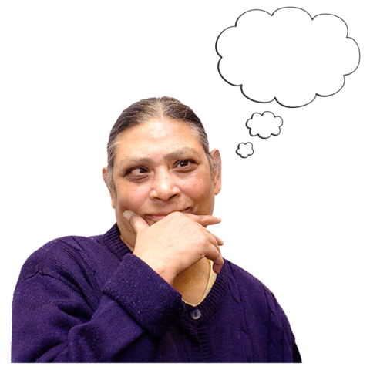
People in other countries can now:
- make this project happen in their own countries

- start a new project like this one
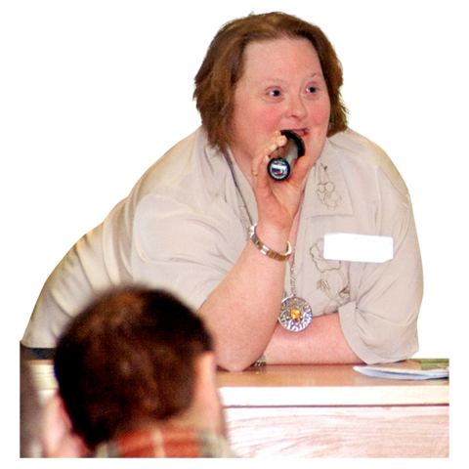
The ideas were also talked about at some big meetings about women and violence.

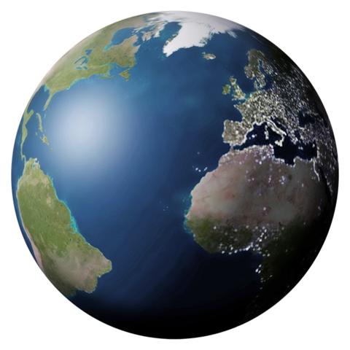
What next?

We will have 2 meetings in Africa and Latin America.

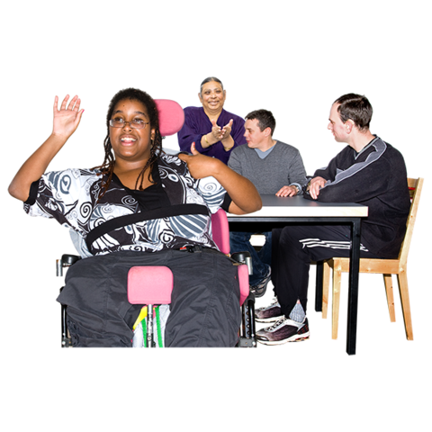

At the meetings people will talk about:
- good ideas to make the lives of women and girls with disabilities better

- how to help more people use these ideas

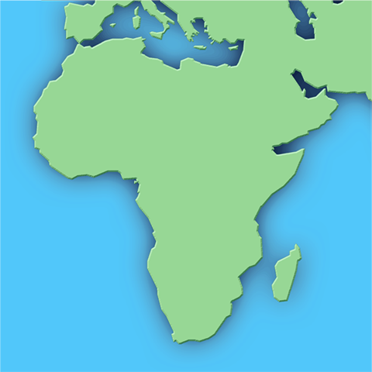

Good ideas from Africa

We asked for good ideas from Africa to help stop violence against women and girls with disabilities.

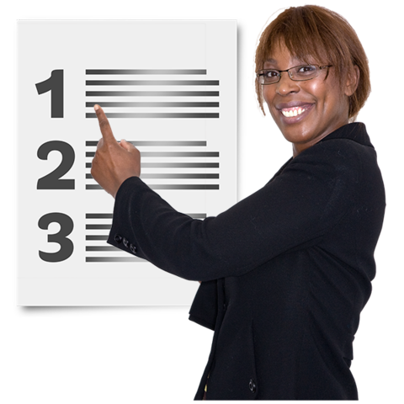
People can use these ideas to make plans and change things.

A group of people that helps to make
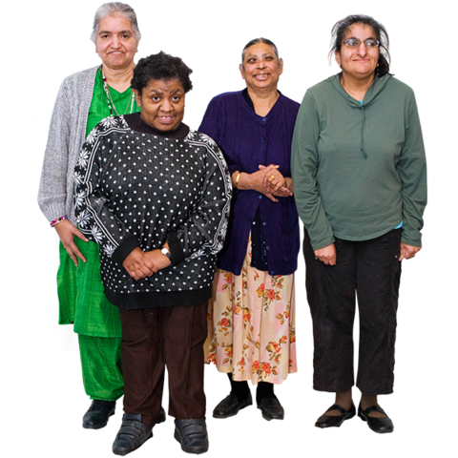
the project work

In 2014 a new group was set up.

Most of the group are women with disabilities.

The group does things like:
- work with people who know a lot about women with disabilities

- make decisions about the project

- choose good ideas to share

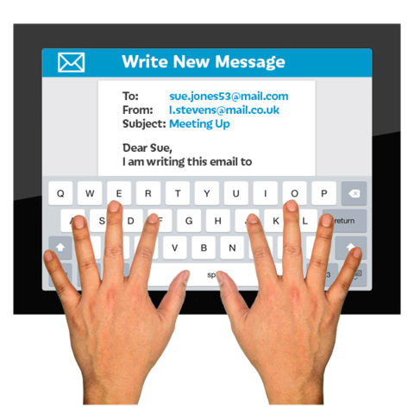
To find out more
Email: lfenu@handicap-international.org
Twitter: @MIW_CRPD
Facebook: https://www.facebook.com/MakingItWorkCRPD/
Pictures by Photosymbols

